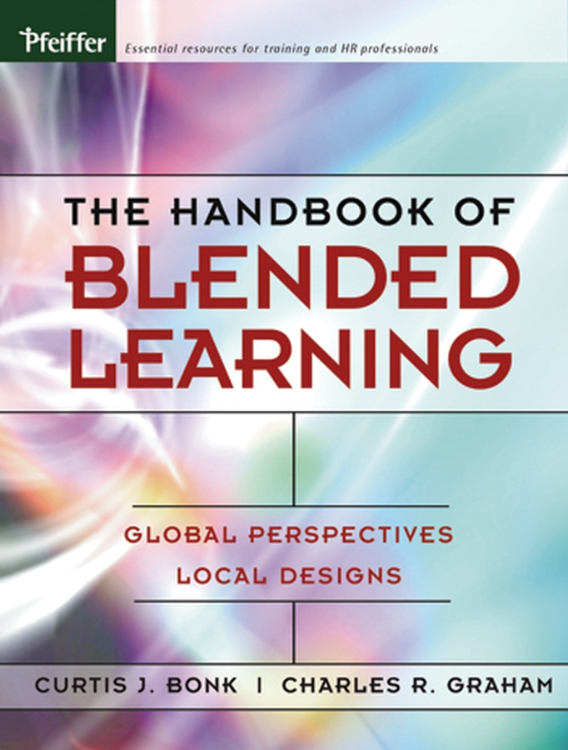

The Handbook of

Blended Learning
Global Perspectives

Local Designs

Curtis J. Bonk
Charles R. Graham

Blended learning is one of the most talked about trends among training professionals today. Spotlighting the best work of the leaders in the field, this book is the most comprehensive discussion of
the topic ever to be published.

Available November 2005

The Handbook of Blended Learning is the first book to provide a forum for issues surrounding the design and implementation of blended learning environments. The book explores the successes and failures, the models and research, the latest ideas and examples that are impacting the design of blended learning environments. The expert panel of contributors will increase awareness of trends and critical issues that readers must consider before launching a blended learning project.
The all-star list of contributors include: Brian Lindquist, Assoc. VP for Academic Affairs, Dean, the College of Graduate Business & Mgmt, University of Phoenix; Pam Pease, Pam Pease & Assoc., past President, Jones International University; Mike Offerman, President, Capella University; Ron Oliver, Edith Cowan University, Australia; Gilly Salmon, Professor of e-Learning and Learning Technologies at the University of Leicester; Jay Cross, Internet Time Group; Lutz Ziob, General Manager, Microsoft Learning; Ellen Wagner, Macromedia; Robert Wisher, Director, Advanced Distributed Learning Initiative, Office of the Under Secretary of Defense; Nancy J. Lewis, VP, On Demand Learning, IBM
Curt Bonk, Ph.D. is Professor of Educational Psychology and Instructional Systems Technology at Indiana University. He has received numerous awards and distinctions in the field of distance learning for his innovative instruction and research. He is a founding member of the Center for Research on Learning and Technology at IU and a Senior Research Fellow with the Advanced Distributed Learning Lab within the Department of Defense in Washington, D.C.
Charles Graham, Ph.D. is Assistant Professor of Instructional Psychology and Technology at Brigham Young University and has recently co-edited a series of case studies on blended learning for the Quarterly Review of Distance Education.

Jossey-Bass, A Wiley Imprint · 10475 Crosspoint Drive, Indianapolis, IN 46256 · PH: 800.956.7739 · FX: 800.605.2665 · www.jbp.com


Please send me the following: The Handbook of Blended Learning: Global Perspectives, Local Designs
Curtis J. Bonk, Charles R. Graham
ISBN: 0-7879-7758-6 List price: $75.00 Paper p. 600+

Name __________________________________________
Address_________________________________________
_________________________________________
City_______________________ State______Zip________
Payment Enclosed. All payments must be in U.S. dollars. 4/13/05
(Payable to John Wiley & Sons)

Check/Money order
Visa
American Express
MasterCard
Card no. |_|_|_|_|_|_|_|_|_|_|_|_|_|_|_|_|
Exp. Date___________ Day Phone____________
Signature__________________________________

Prices listed are for domestic United States customers and are subject to change without notice. Availability subject to stock on hand.

Book Price $______ Shipping $______ Sales Tax $______ Total $______
Please add shipping charges:
MerchandiseSurface 2-Day 1-Day
First Book$5.00 10.50 17.50
Each additional book $3.00 3.00 4.00

Quantity discounts available. Please call 800.956.7739.

